Concrete Quality Attribute Scenarios Evaluation
Evaluator: Daniel Andarge

Scenario 1
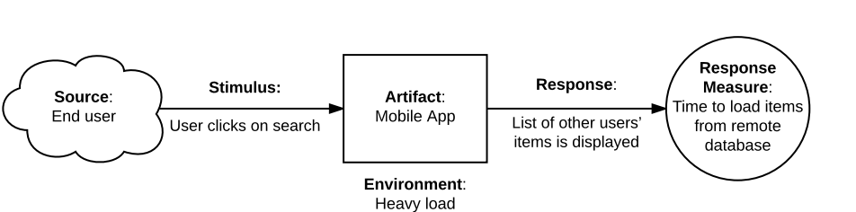
Quality Attribute: Performance
Attribute Refinement (Sub-Type): Responsiveness
Classification: Sensitivity Point
Explanation: The scenario underscores the importance of performance in loading items from a remote database upon a user's search action in a mobile app. Within this context, responsiveness emerges as a critical aspect, emphasizing the system's capability to deliver timely and interactive feedback to user inputs. Consequently, the efficiency of loading items from the remote database stands out as a pivotal sensitivity in this scenario.

Scenario 2
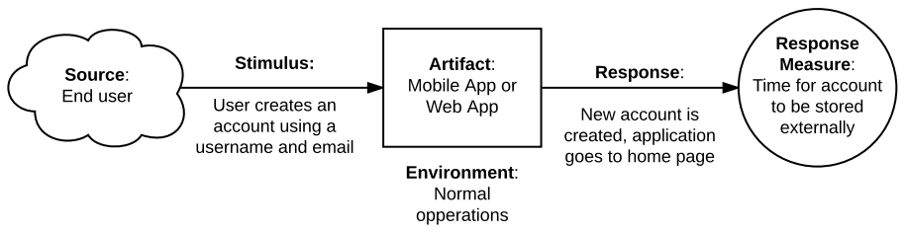
Quality Attribute: Performance
Classification: Sensitivity Point
Explanation: The scenario indicates the importance of performance, specifically the efficiency and speed of storing the account information externally.Considering that the current system has already implemented the authentication mechanism, the performance of storing the account externally becomes a sensitivity point.

Scenario 3
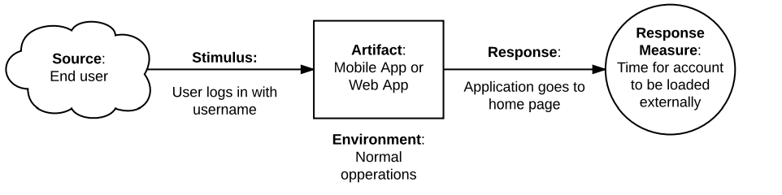
Quality Attribute: Performance
Classification: Sensitivity Point
Explanation: The scenario focuses on the performance aspect of the system, specifically measuring the time it takes for an account to load externally after a user logs in with their username. In this scenario, the performance of the system is a sensitivity point. The system's ability to load the account externally within an acceptable time frame is critical for providing a responsive and efficient user experience.

Scenario 4
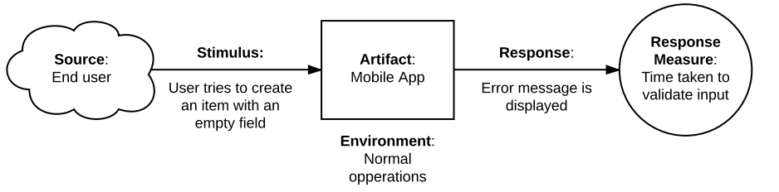
Quality Attribute: Reliability
Attribute Refinement (Sub-Type): Error Handling
Classification: Non-risk
Explanation: With the error handling mechanism already implemented, the scenario primarily focuses on the reliability of the application. The response measure, which is the time taken to validate input, reflects the importance of consistent and accurate handling of user input.Therefore, the quality attribute for the scenario remains as reliability with sub-type of Error hadling , but it is classified as non-risk due to the existing mitigation measures.

Scenario 5
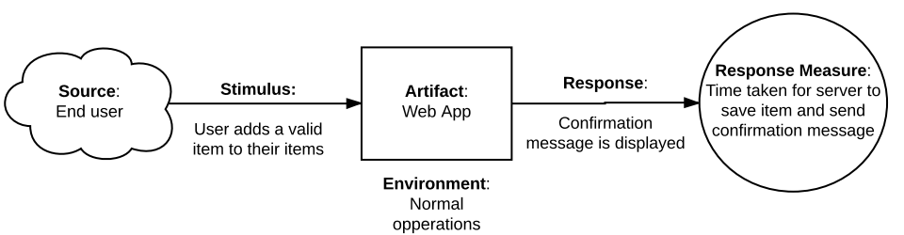
Quality Attribute: Performance
Classification: Sensitivity Point
Explanation: The scenario focuses on the performance aspect of the application, particularly the time taken for the server to save an item and send a confirmation message to the user.The sensitivity point in this scenario lies in the performance of the application, specifically in terms of responsiveness and efficiency.

Scenario 6
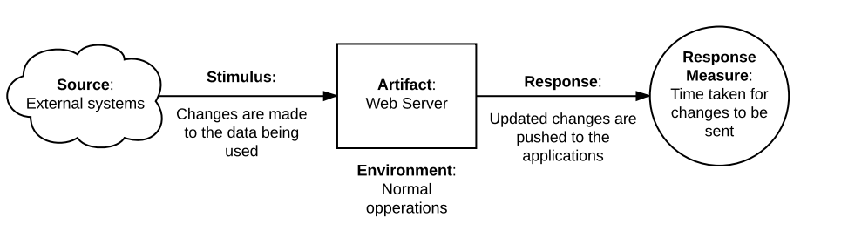
Quality Attribute: Interoperability
Attribute Refinement (Sub-Type): Syntactic Interoperability (Shared Storage)
Classification: Risk
Explanation: The scenario underscores the need for seamless interoperability between local storage and external systems, evident in the response time for changes to propagate. Overcoming interoperability challenges and risks is vital. This entails implementing data transformation mechanisms, adhering to standards, and robust integration techniques in the application's architecture.
the expected response should swiftly display the list of relevant items
Scenario 7
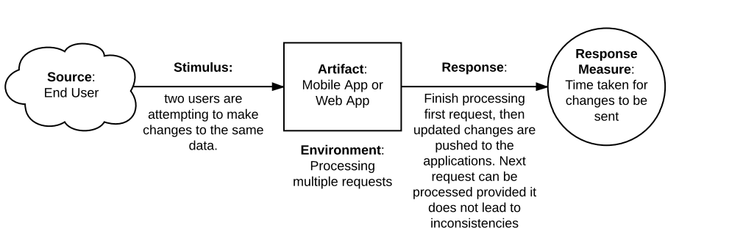
Quality Attribute: Reliabilty
Attribute Refinement (Sub-Type): Data Integrity
Classification: Tradeoff
Explanation: In this scenario, Data Integrity is the Quality Attribute which is sub-type of Reliability, categorized as a tradeoff. Balancing between consistency and responsiveness arises when multiple users attempt simultaneous data modifications. Employing the command pattern for concurrent updates ensures controlled processing to prevent inconsistencies but might introduce delays as subsequent requests await completion of preceding ones.

